High School based Dual Enrollment

Directions for Paying Tuition Online

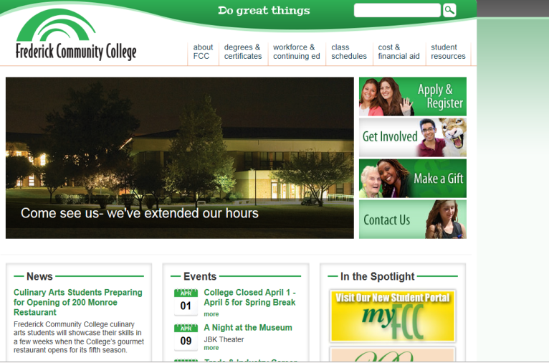For school based dual enrollment students, the high schools work directly with FCC to register students. Once a student is registered for a course and a schedule is created, an electronic invoice is automatically generated and sent to the student’s FCC email account. Students who completed the online application to FCC should have received an admissions letter. The student ID number and email account information is included in the letter. If a student applied but did not receive a letter, contact the Admissions Office (301-624-2716). Payment directions are below. Contact the Bursar’s office with questions about payments (301-846-2456).

1. Go to www.frederick.edu

Click on **Visit our Student Portal**



1. 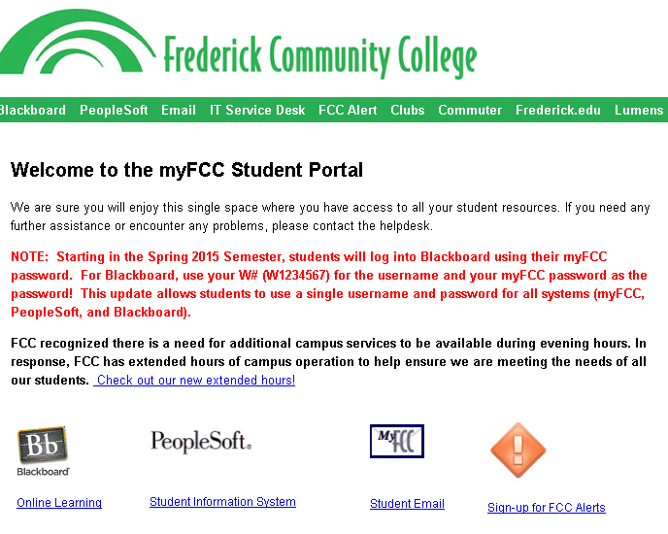Click on **PeopleSoft** icon



1. Enter username (W + FCC student ID) & Password (First two letters of last name+ last 5 digits of the student ID)

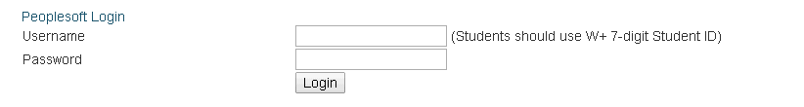

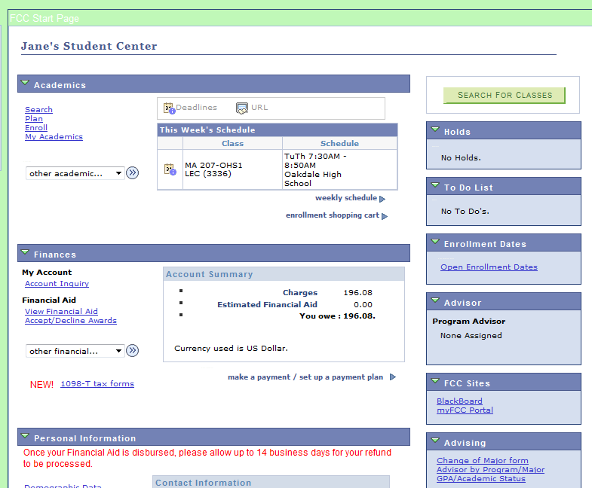

1. This is an example of the Student Center.

This shows the courses in which you are enrolled

and the tuition payment required.

Be sure the course(s) information is correct.

**If the course information is NOT correct,**

**contact your high school counselor to update the information.**

1. 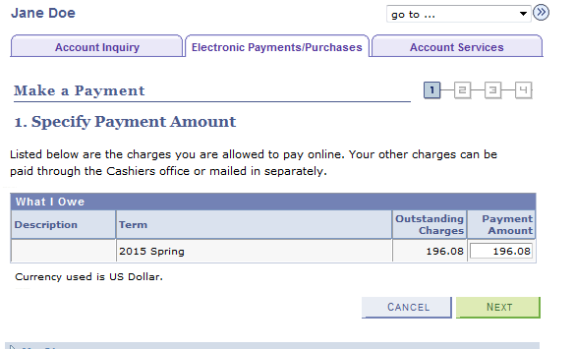If all course information is correct, enter the payment information.

When paying through the student center, you must pay the full amount.

If you need to request other payment arrangements, contact FCC (301-846-2456).

1. 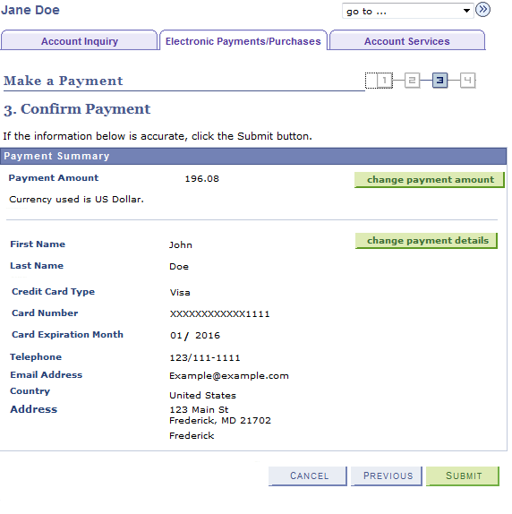Complete the information required, confirm payment and submit.

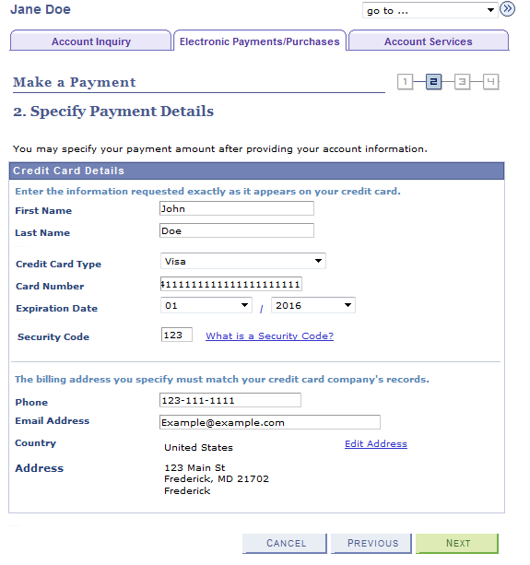

1. 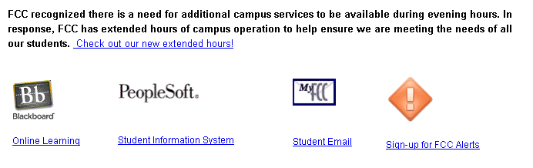Once you payment has been submitted, you will receive a confirmation email that is sent to your FCC student email account.