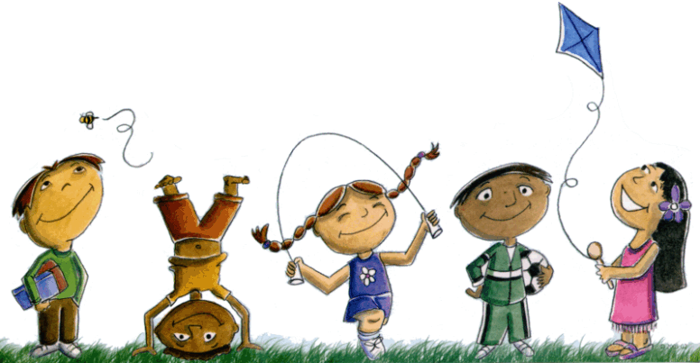

**Field Day 2019 – May 24th**

**Optional T-shirts for purchase**

**This color will follow each grade until 5th Grade.**

**Yellow: Kindergarten Red: 3rd**

**Green: 1st  Orange: 4th**

**Blue: 2nd  Red Tie-Die: 5th \***

***\* These shirts will have 5th grade student names & are especially designed for 5th grade Students. ☺***

Please fill out the bottom portion and return to your classroom teacher by **March 15**.

*Checks need to be made out to North Frederick Elem.*

**Student Name:_____________­­­_____________ Teacher:_______________________ Amount Paid:________ Check#________**

**Size: (please check one) Cost: $7.00 for each shirt (PK-4th) Cost: 5th Grade Tie-Dye $10.00**

**Youth Small _______ Adult Small_______ Color T-shirt________**

**Youth Medium _______ Adult Medium______ Color T-Shirt________**

**Youth Large _______ Adult Large _______ Color T-Shirt________**

**Youth X-Large _______ Adult X-Large______**

**Adult XX-Large_____ (+$2.00)**

**Sweatshirts in the same design are available for $20.00. Color Gray only Size __________**

***We need a separate form for each child or parent order***

**Amount Paid:__________**