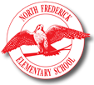 North Frederick 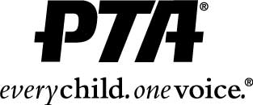
Elementary School
PTA

THAT’S RIGHT ... Our Spring Fundraiser is extra sweet this year!
Buy and sell DISCOUNTED TICKETS to Hershey Park.

DETAILS:
- Tickets are $37.95 – a 54% savings!
- Tickets are for ages 3 and up
- Tickets are valid May 3 – September 29, 2019
- All orders along with one check for payment due by March 15th
PTA will distribute tickets on/or before the week of April 29th. A distribution plan will be communicated once we have the tickets in hand.

INCENTIVES:
YOU earn a free ticket for every 10 Hershey Park tickets sold!
Top selling class will earn their teacher 2 Hershey Park tickets & a class pizza party!

NOW don’t forget to tell your friends, family and co-workers about this SWEET DEAL they won’t want to miss …. while helping support our school!

Name | Contact Information | # of Tickets purchased
*Please keep this at home for your records & ticket distribution.

