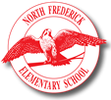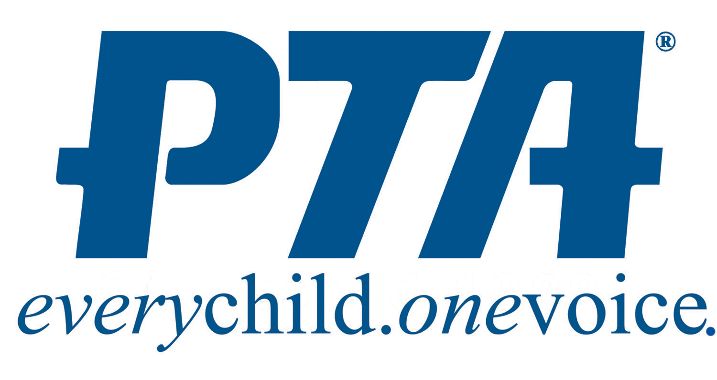

CLUB FAIR! THURSDAY 9/26 5-6pm @ NFES Cafeteria

Meet instructors, learn about programs and have first sign up opportunity*
Online Sign Ups open Friday, 9/27 @ http://bit.ly/NFESCLUBSIGNUPS

- In School:
  - Rocketry 5th (first session October 30^{th,} 2019. Second session TBA Spring 2020)
  - Robotics – 4^{th-}5th (first session October 2nd, 2019. Second session TBA Spring 2020)
  - Fit to Be/Music in Motion, K-5th (TBD fall/winter)
  - Hero Boys Running – Ms. Clarke Hooper, 3rd-5th (October – December)
    - Thursdays, 3:00-4:00
  - Volleyball – Ms. Prouty
    - Rotating six-week sessions, Mon/Weds
    - Grades 1-2 / Grades 3-5
  - Choir, 4/5th Thursdays, 3:00-4:00 (year-round)

- PTA Sponsored:
  - Maryland Ensemble Theater drama production
    - (October-early March), M/W
    - K-5th grades

  - Rosehill Manor “Time Machine” History Club
    - Two 6-week Sessions: October/March
    - Grade 2nd-5th

  - Intro to Machine Sewing with Ms. Mary Ann
    - K-5th
    - Four weeks EACH: Thurs/ Fri in October (student chooses one day)

  - Soccer Club, K-5th grades
    - Recreational game play; non-competitive
    - Thursdays from 3:15-4:15 / September 30- early November

  - Art Club - Makers Market: Exploring Your Creativity
    - Painting, clay, science, building and more! Take home what you create.
    - Mondays K-2nd / Thursdays 3rd-5th 3:15-4:30pm

- Outside Partners:
  - Girls on the Run – (Sept. through Dec. 7) 3-5th grade; M/W
  - Girl Scouts – Tuesday evenings, off site
  - YMCA
  - Kids Club
  - Boys & Girls Club

*For hard copy forms, see the front office.
**Early sign up does not guarantee placement; all al placements subject to approval.

