January 12, 2024
FROM: Barbara Wagner, Frederick County Election Director
RE: High School Election Workers (Judges)
The Frederick County Board of Elections office would like to encourage eligible high school students the opportunity to participate in the civic process as election workers (judges) in the 2024 primary and general elections. The Primary election will be held on Tuesday, May 14, 2024, and the General election will be held on Tuesday, November 5, 2024.
Students can earn Student Service Learning credit for the time they work. Students should complete the Volunteer Hours and Community Service Form, have it signed by the Election Site Supervisor and submit to their high school’s Student Service Learning Coordinator. Alternately, there is an option for pay if students do not need the credit.
There are age requirements. Students who are 18 must also be a registered voter. Students who are 16 or 17 years old can also apply. They must preregister to vote and complete the parent permission form available through the QR code below.
All the information: requirements, dates, training, job descriptions, etc. are available through the QR code.
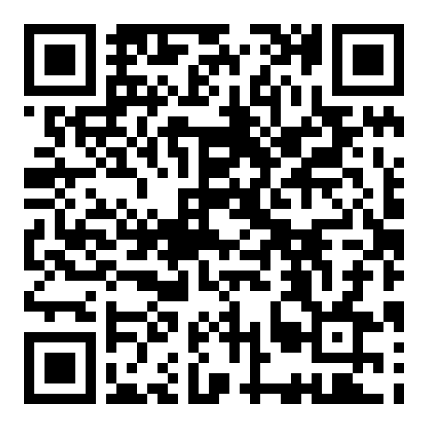
We appreciate your consideration and look forward to hearing from you.

