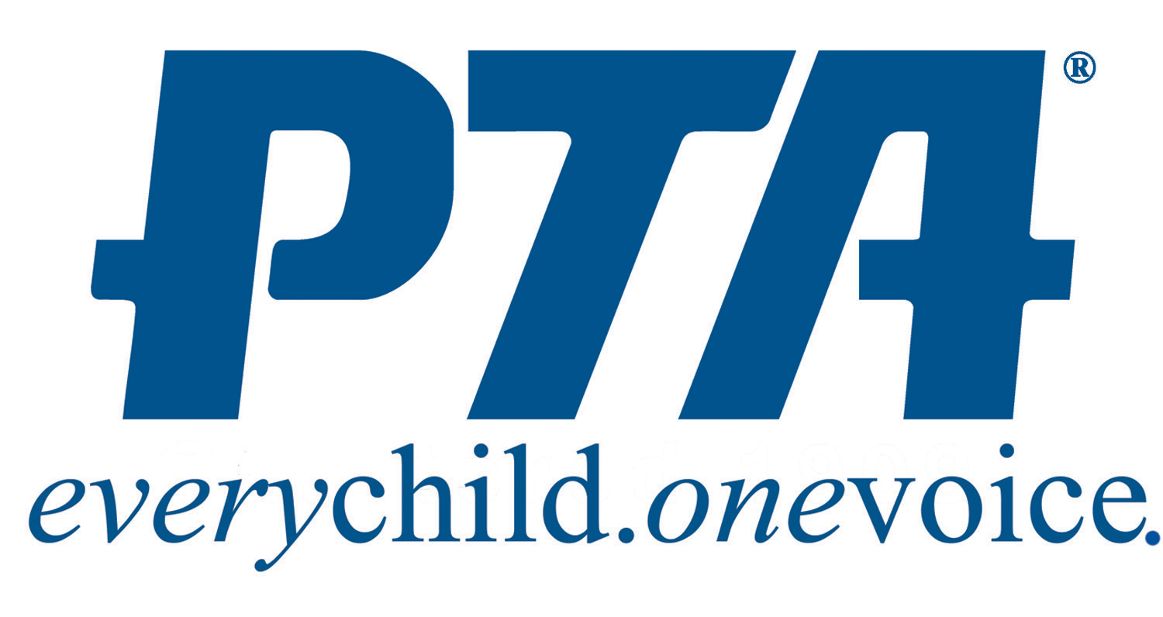

- In School:
  - History Bee, 3rd-5th grades, Wednesday 3:00-4:15. SEE MRS. ANDERSON.
  - Basketball Club
    - Mr. Moses K-1, Wednesdays, 3:15-4:15
      - 1st Session: 1/8-2/12
      - 2nd Session: 2/19-3/15
      - $5 per student
    - Ms. Hudson: two sessions TBA – 2nd/3rd & 4th/5th
      - Day of the week TBA
      - Session Dates TBA
      - FLYER COMING HOME AT LATER DATE

- PTA Sponsored:
  - Maryland Ensemble Theater drama production
    - Auditions Closed; Performances Friday March 6 and Saturday March 7th

  - Coding for Girls - Taught by parent David Fox
    - Fridays till 4:15
    - Session Dates: 1/3/2020 - 5/15/2020 (except 2/14 & 4/10)
    - 2nd Grade Only. Limited to 20 Students
    - No Charge

  - Chess Club by Silver Knights Enrichment
Learn and improve at chess through lessons and games while practicing critical thinking and problem-solving skills.
    - K-5th
    - 10 weeks, Wednesdays, January 15 – April 1 (no club 1/29, 3/4, 4/8)
    - Dismissal till 4:15
    - $145 per student

  - Young Rembrandts Drawing Classes for Kids
    - K-5th
    - Mondays till 4:15 / 10 weeks (1/13/20 - 3/30/20 (no class 1/20 & 2/17)
    - $125, payment plans available. All supplies included.
    - ONLINE SIGN UP www.youngrembrandts.com/md

  - Beginner Crochet with Ms. Randi
Learn basic stitches and finish with a wearable scarf with fringe by the last class.
    - 8 weeks: Thursday January 16-March 5 till 4:15
    - Grades 1-5
    - $80 per student. All materials included.

  - Intro to Machine Sewing with Ms. Mary Ann
    - K-5th
    - Four weeks: Fridays - Jan 3, 10, 17, 31 till 4:15
    - $100 per student, all supplies included

  - Intermediate Machine Sewing with Ms. Mary Ann
    - Three weeks Fridays - March 13, 20, 27 till 4:30
    - FASHIONISTA! Choose from PJ pants, skirt or shorts. Time permitting, add scarf, scrunchie or bag. Bring your favorite fabric.
    - 2-5th grade, Must know basics of machine sewing.
    - $100, BYO fabric

  - Early Dismissal Sewing with Ms. Mary Ann
Valentine’s Session for Intermediate sewers. MUST know basic machine sewing. Make a letter pillow, heart or bag.
    - 2/14 – Dismissal until 4pm.
    - $55, All supplies included.

  - Intro to Machine Sewing with Ms. Mary Ann Half Day Class
Learn basics and safety and make a pillowcase and bag.
    - March 4th, Dismissal until 4pm
    - 2nd-5th grade
    - $75, all supplies included

*All sign ups subject to approval.

