THS Class of 2020
Safe and Sane
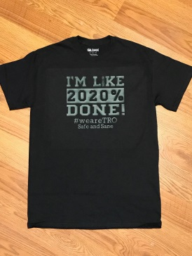
T-Shirts $20 XS-XL $25 2XL-5XL
Available in sizes XS – 5XL

Size | XS  $20 | S  $20 | M  $20 | L  $20 | XL  $20 | 2XL  $25 | 3XL  $25 | 4XL  $25 | 5XL  $25 | Total
Quantity
Amount | $ | $ | $ | $ | $ | $ | $ | $ | $ | $

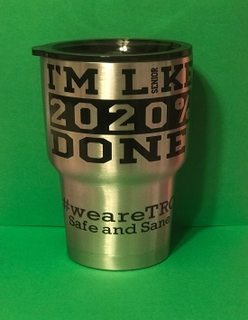
Tumbler $25

Quantity |  | X $25 = | $

Name: |  | Flex Teacher:

Totals
T-Shirts | Quantity |  | Amount | $
Tumblers | Quantity |  | Amount | $
 |  |  | Total | $

