|  |
| --- |
|  |
| Carroll Manor Elementary Music Newsletter |
|  |

Carroll Manor Music

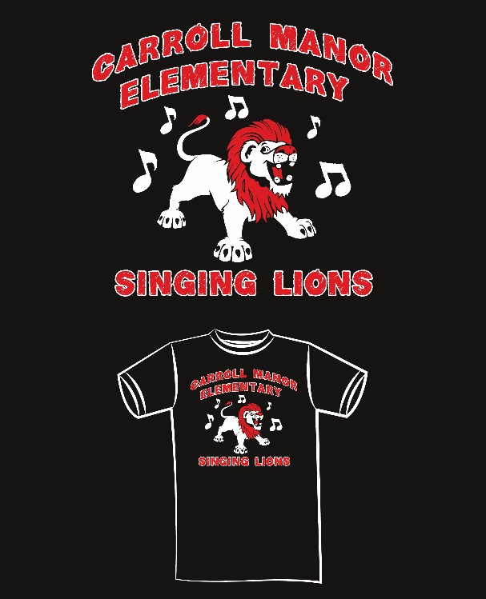

|  |
| --- |
|  |
|  |
|  |
| Singing Lions Chorus The Singing Lions chorus has started and is in full swing! It is open to all 3rd, 4th, or 5th grade students who love to sing!  **Want to Volunteer?**  The chorus is in need of parent volunteers to be at chorus rehearsals and events this year.  If you are interested in volunteering for chorus please e-mail Ms. Fritton! |
|  |



♫ Ann Fritton – [ann.fritton@fcps.org](mailto:ann.fritton@fcps.org)

♫ Marc Smith – [marc.smith@fcps.org](mailto:marc.smith@fcps.org) (M, Th, & F)

♫ Sarah Knox – [sarah.knox@fcps.org](mailto:sarah.knox@fcps.org) (Th)

|  |
| --- |
|  |
| Dear CMES Parents and Guardians,  Welcome to a new school year of music at Carroll Manor! This year we are excited to welcome two new music teachers, Mr. Marc Smith and Mrs. Sarah Knox to our specials team!  Mr. Smith is excited to be at CMES! He is originally from PA and graduated from Temple University. He has taught music for 16 years in both Baltimore and Frederick. He enjoys exercising, cooking, reading, watching movies, and spending time with family.  Mrs. Knox is a Frederick county native from Middletown valley. She is in her 8th year teaching and currently teaches at Walkersville Elem. the other days of the week. She lives in Smithsburg with her husband, 1 ½ yr. old son Tate, and their goofy French bulldog Nacho.  This newsletter contains our grading and effort policy for music as well as what your children will be learning in music this first quarter of the school year.  We are excited to help your children grow as musicians this school year!  Ms. Fritton, Mr. Smith, and Mrs. Knox |
|  |

## 

## Elementary Music Grading and Effort Policy

|  |  |  |
| --- | --- | --- |
| **Grades K-5 Term Report Card Grade** | | |
| **What We Measure (Categories)** | **Evidences**  **(Assignments)** | **Weighted Percentages** |
| **Classwork** | * Lesson Activities * Techniques * Product/Performance * Participation * Formative Benchmarks | 70% |
| **Assessments** | * County Summatives * Teacher Created | 30% |
| **Grades 1-5 Effort Report Card Grade** | | |
| **Effort** | * As determined by teacher | 100% |

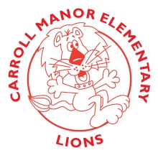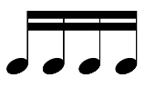

 Music Concepts and Goals

 1st quarter of 2018-2019

|  |  |  |  |  |  |
| --- | --- | --- | --- | --- | --- |
| **Grade** | **Rhythm** | **Melody** | **Tone color** | **Creative Expression/ Expressive Elements** | **Harmony** |
| **Kindergarten** | Steady beat | Singing voice/ singing in a group  Matching pitch  High, low, same  Sol and Mi | Using different voices: Singing, speaking, whisper, shouting  Exploring classroom instruments | Exploring personal and shared space | Exploring Major and Minor |
| **1st** | Steady beat  Long and short sounds | Matching pitch  High, low, and same  Sol and Mi | Using different voices: Singing, speaking, whisper, shouting  Exploring classroom instruments | Loud and quiet  Fast and Slow | Exploring Major and Minor |
| **2nd** | Steady beat  Strong beat  Duple and Triple meter  Ostinato  Quarter note, pair of eighth notes, quarter rest, and half note  Notating rhythms | Matching pitch  Sol, Mi, and La | Exploring classroom instruments | Exploring personal and shared space  Creative movement | Exploring Major and Minor |
| **3rd** | Reviewing rhythm  Dotted half note, half rest  Rhythmic dictation | Sol, Mi, La, Do, Re, high Do  Step, skip, repeat | Exploring classroom instruments | Creative movement | Major and Minor |
| **4th** | Reviewing rhythm  Time Signatures | Treble Clef pitches Low D to High G  Leaps | Classroom instruments | Creative movement | Major and Minor |
| **5th** | Reviewing rhythm  Syncopation  Dotted Quarter/Eighth note combination | Reviewing Treble Clef pitches  Adding Low C and High A  Low Sol, Low La, Do, Re, Mi, Fa, Sol, La, Ti, High Do | Classroom Instruments | Creative Movement | Major and Minor |