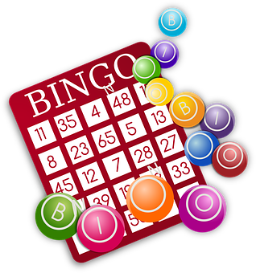
TUSCARORA HS INSTRUMENTAL MUSIC BOOSTERS
BINGO
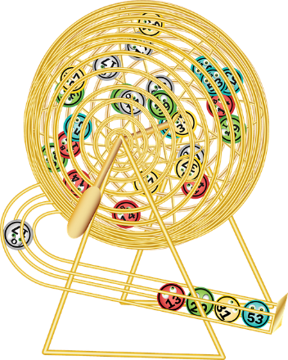
Fraternal Order of Eagles
401 Central Ave, Brunswick, MD
Saturday, April 30, 2022
Doors Open at 11:00 am
Games begin at 1:30 pm
20-$150 Games Guaranteed
Jackpot: $500 Guaranteed
Tips Raffles
50/50 Bingo Games (3 cards)
Buy Early-$35 in Advance
$40 at the door
(Ticket includes nine card & lunch)
Extra Packs will be available
FOR TICKET INFORMATION CONTACT:
Shannon Goodman — 240-678-0312
For more info: http://www.THSIMB.org
Fundraiser benefits the
Tuscarora High School Instrumental Music Program

